1. **EMAIL VERIFICATION: Email received by Business Owner right after sign up :**

Sender: [support@juzzpa.com](mailto:support@juzzpa.com)

Subject: verify your Juzzpa email

Dear <Name>,

Thank you for signing up with Juzzpa – a new and effective way to manage your business.

To complete your sign up, verify your e-mail address by clicking on the button below:

VERIFY EMAIL ADDRESS

Or copy and paste the following link in your browser: <link>

Please note that the verification link will expire in 7 days. If you face any problems or have questions, write to us at [support@juzzpa.com](mailto:support@juzzpa.com) or call us at 080- XXXXXXX

1. **SMS received by Business Owner right after sign up :**

Sender: JUZZPA (short code)

Content:

Thank you for signing up with Juzzpa. A verification link has been sent to your email ID. To complete your sign up, please verify your e-mail within 7 days.

1. **REDIRECTION PAGE: when User Clicks on ‘VERIFY EMAIL’ button (within 7 days) for first time:**

**E-mail verification successful!**

Your e-mail has been verified. You can now login into your Juzzpa account. You will be redirected to Juzzpa website in 10 seconds.

e.g.:

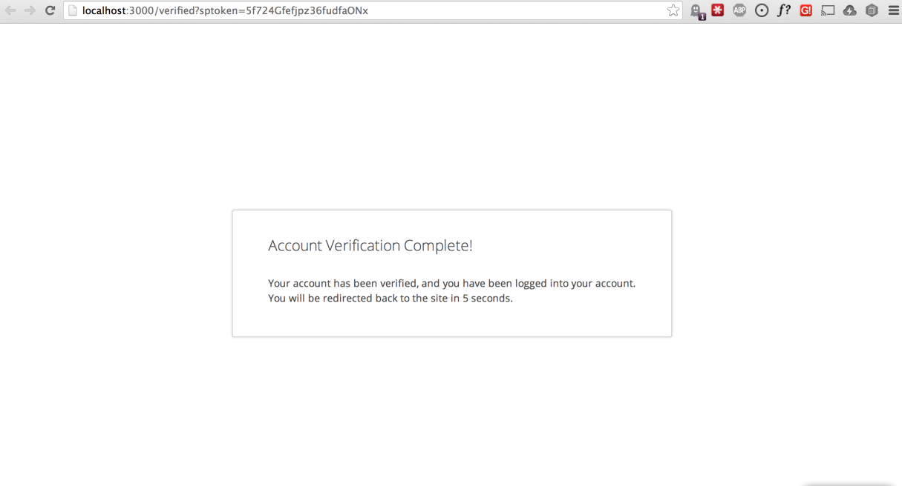

1. REDIRECTION PAGE: when User Clicks on ‘VERIFY EMAIL’ button for 2nd time (after successful e-mail verification):

**E-mail already verified!**

Your e-mail has already been verified. You can log into your Juzzpa account. You will be redirected to Juzzpa website in 5 seconds.

1. Redirection Page when user clicks on ‘VERIFY EMAIL’ button without completing email verification within 7 days:

**E-mail verification link expired!**

Your e-mail verification link has expired. You will be redirected to Juzzpa website where you will be able to resend the verification link.

1. In case 5, the user will be redirected to a page on Juzzpa website where he/she should be able to resend link without entering/ changing the e-mail ID being displayed.

Your registered e-mail address is [acbd@gmail.com](mailto:acbd@gmail.com). Click on the button below to resend the email verification link.

RESEND VERIFICATION EMAIL

1. **WELCOME MAIL: Email received by BO right after successful Verification of the email**

Subject:Welcome to Juzzpa

Dear <Name>,

Your email address has been verified.

Welcome to Juzzpa – A new and effective way to manage your business.

Juzzpa helps you ensure a pleasant experience for your customers by taking care of all your store management needs and letting you do what you do best – taking care of your customers.

**TRACK YOUR BUSINESS DATA**

* Know who are your customers
* What services they like/ dislike
* Performance of your staff

**MANAGE YOUR STORE AND STAFF**

* Manage all your stores from one window
* Record and manage your staff information
* Map your staff to stores

**EASY TO MANAGE APPOINTMENTS**

* Manage all your appointments at one place
* Send appointment reminders to your customers
* Reschedule appointments

Now that you are aboard Juzzpa, we would like to know more about you and your business. Sign in to your Juzzpa account here:

SIGN IN

If you face any problems or have questions, write to us at [support@juzzpa.com](mailto:support@juzzpa.com) or call us at 080- XXXXXXX

Warm Regards,

Team Juzzpa

1. **SMS Content for Welcome Email:**

Welcome aboard ! Your email is verified. You can now access your Juzzpa account. We’d like to know more about you. Plz login and complete your business details.

1. **Message on website when business details submitted successfully (Pre curation).**

**Thank you for telling us about your business!**

We have received your business details. Someone from Juzzpa team will soon get in touch with you to verify the same. Once verified, your account will be activated for you to use it.

Team Juzzpa

1. **SMS Upon submission of Business Details (Pre curation)**

Sender: JUZZPA (short code)

Content:

We have received your business details. We’ll get in touch with you soon to verify the same and activate your account

1. **Email Post Successful Curation:**

Sender: [support@juzzpa.com](mailto:support@juzzpa.com)

Subject: Your Juzzpa account is ACTIVE now!

Dear <Name>,

Congratulations! Your Juzzpa account is active now.

We are excited to have you on board. At Juzzpa, we are constantly innovating to find ways to help you run your business smoother. Go ahead and experience Juzzpa. Click here to log in to your account.

ADD STORES

ADD STAFF

MANAGE APPOINTMENTS

ADD SERVICES

We would like to hear from you. Write to us at [support@juzzpa.com](mailto:support@juzzpa.com) or call us at 080- XXXXXXX. Visit us at [www.business.juzzpa.com](http://www.business.juzzpa.com)

Warm Regards,

Team Juzzpa

1. **SMS received by Business Owner after successful curation :**

Sender: JUZZPA (short code)

Content:

Congratulations! Your Juzzpa account is active now. We are excited to have you onboard. Go ahead and experience Juzzpa. Login to your account here.